Internal Load Balancer

Cloud / Internet

TCP , Port 80

PLB

80

80

80

VM3

VM1

VM2

1433

1433

1433

SQL

SQL

SQL

An internal Load Balancer directs traffic only to resources that are inside a Virtual Network or that uses a VPN to access Azure Infrastructure

An internal Load Balancer enables the following of Load Balancing:

Within Virtual Network

For a Cross-Premises Virtual Network

For Multi-tier applications

For line of Business Applications

Steps:

Step 1:

Create VNet

Create 3 Virtual Machine , VM1, VM2, VMTest

Put it in this VNet

Select Availability Set

Create Load Balancer

Internal

SKU Basic :

VNet : Select ur VNet , Subnet

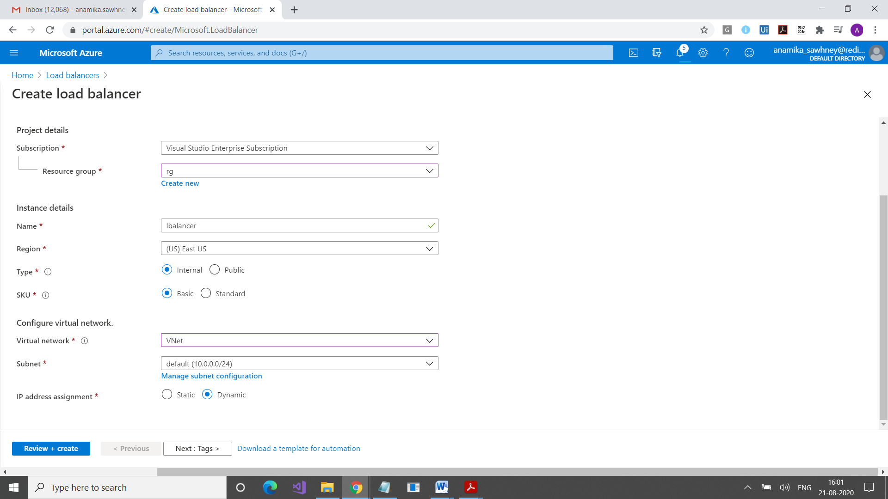

In Backend pool, add 2 vm’s , vm1, vm2

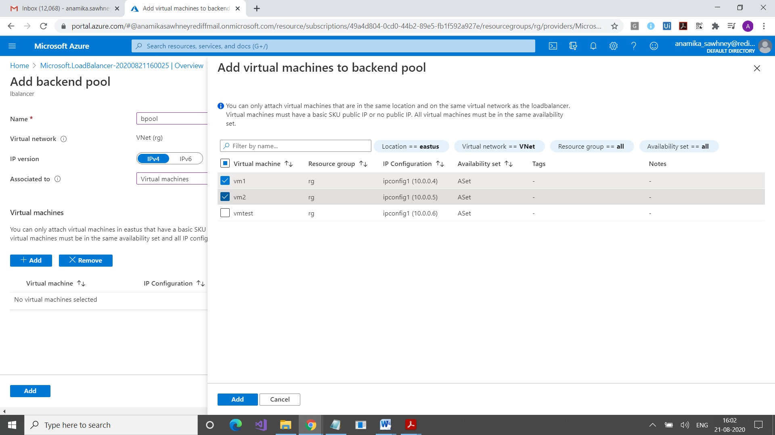

Now connect first vm

Install IIS on it

Do same on vm2

Connect vmtest

Here open Internet Explorer

Copy Private IP of Load Balancer

Type in Browser in vmtest

